Retail Store Sales Insights and Prediction Model-Phase 1

1. Introduction
This project focuses on analyzing retail store sales data to uncover patterns, trends, and insights that can support data-driven business decision-making. The analysis involves data cleaning, exploratory data analysis (EDA), and visualization of key metrics such as sales, profit, customer segments, and discount impact.
1.1 Objective
The objective of this project is to analyze retail sales data to identify key patterns, trends, and factors influencing business performance. The analysis aims to generate actionable insights related to sales, profitability, customer behavior, and regional performance, and to support data-driven decision-making.

2. Dataset Description
The dataset used for this proje ct was sourced from Kaggle, as no dataset was provided by the team. It contains detailed information about retail transactions, including attributes such as Order Date, Product Category, Sub-Category, Sales, Profit, Quantity, Region, Discount, and Customer Segment.
The dataset includes both numerical variables (e.g., Sales, Profit, Quantity, Discount) and categorical variables (e.g., Category, Region, Segment), making it suitable for performing comprehensive exploratory data analysis and deriving meaningful business insights.
The dataset consists of approximately 9994 records and 21 columns, providing sufficient data for meaningful analysis of sales trends, customer behavior, and business performance.

2.1 Tools and Technologies Used
- Python (Pandas, NumPy) for data cleaning and preprocessing
- Matplotlib and Seaborn for data visualization
- Power BI for dashboard creation
- Jupyter Notebook for analysis and development
- GitHub for project version control and sharing

3. Data Cleaning
- Removed duplicate records to ensure data consistency
- Handled missing values appropriately
- Converted date columns into datetime format
- Standardized column names for better readability
- Created new features such as Year and Month
- Created a new feature called Profit Ratio

4. Exploratory Data Analysis
4.1 Sales Distribution
A histogram was used to analyze the distribution of sales values. It was observed that most transactions involve lower sales amounts, with a few high-value transactions, indicating a right-skewed distribution.
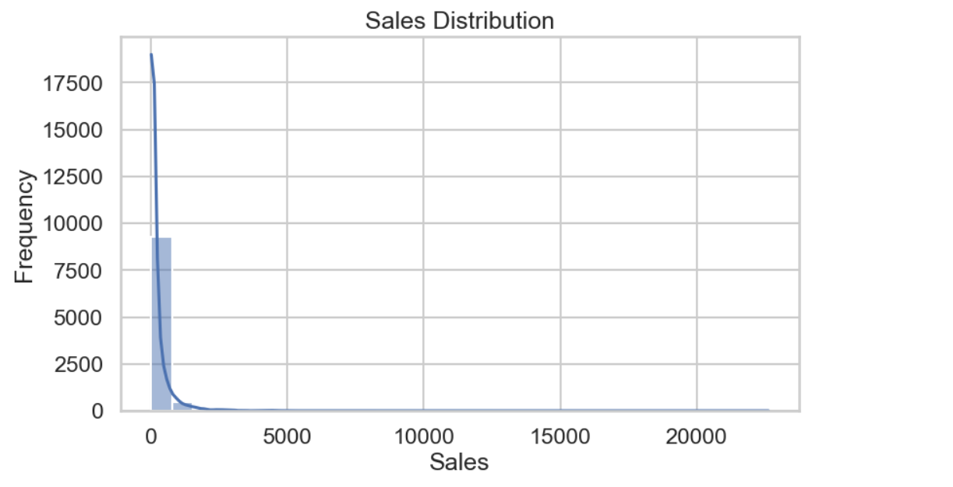
4.2 Quantity Distribution
The distribution of quantity sold per transaction was analyzed, showing that most orders consist of a small number of items.
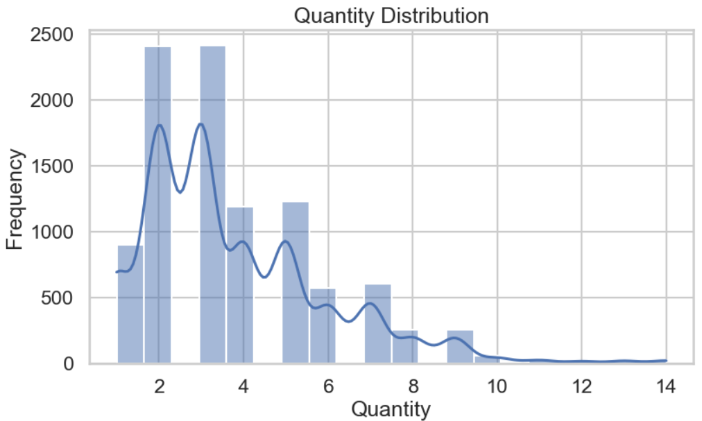

4.3 Category-wise Sales Analysis
The analysis revealed that the Technology category generates the highest sales among all product categories, making it a key contributor to overall revenue.

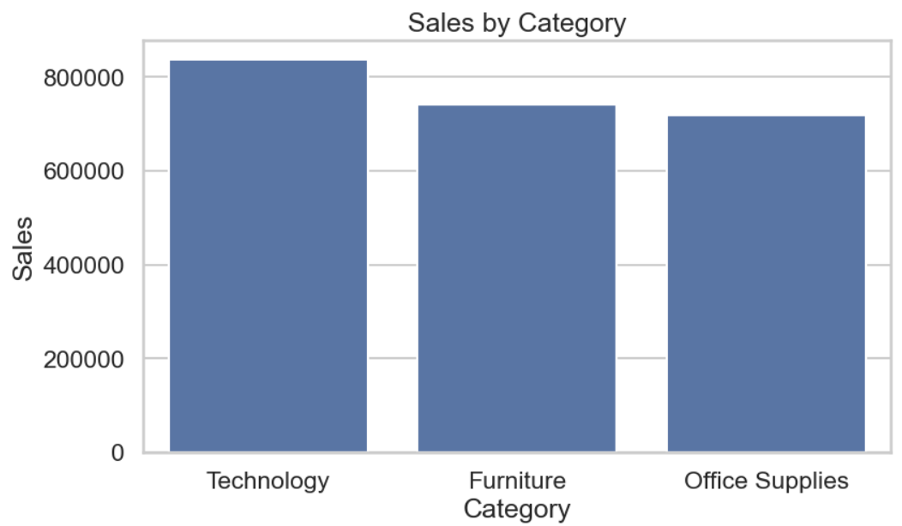
4.4 Region-wise Profit Analysis
The West region contributes the highest profit, indicating strong business performance in that region compared to others.
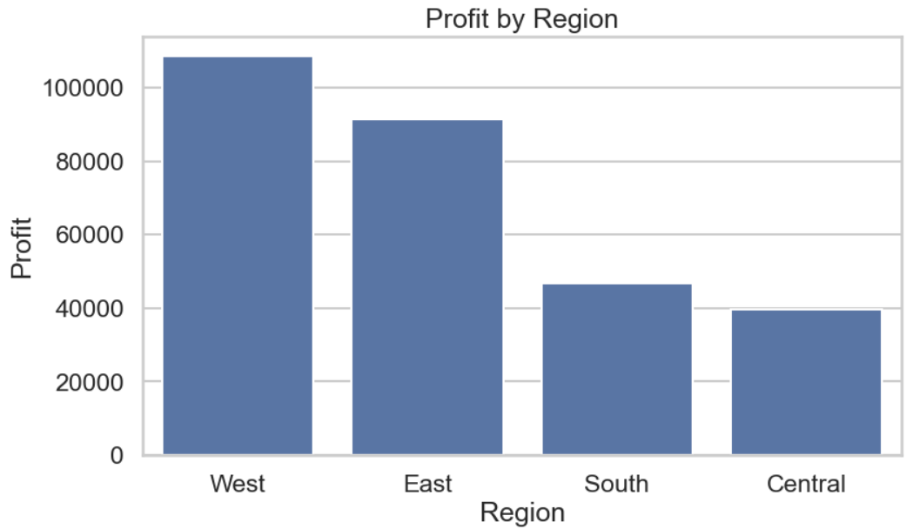
4.5 Customer Segment Analysis
The Consumer segment contributes the largest share of total sales, followed by Corporate and Home Office segments.
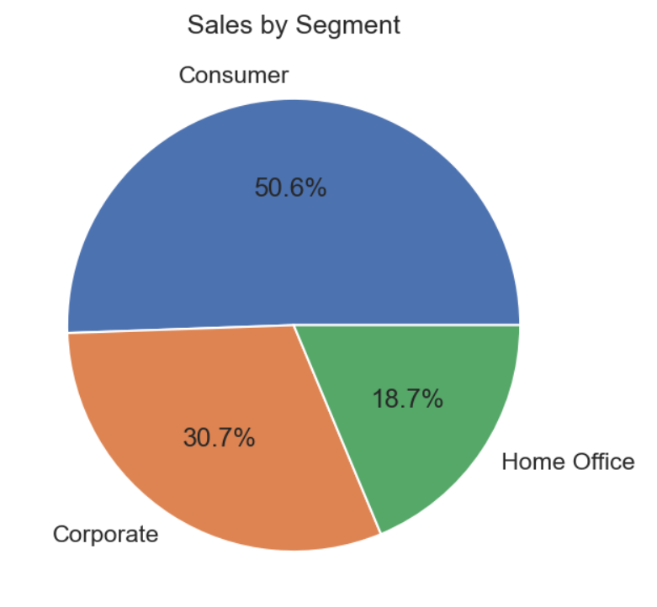
4.6 Monthly Sales Trend Analysis
Time-series analysis indicates seasonal variations in sales, with certain months showing peak performance.
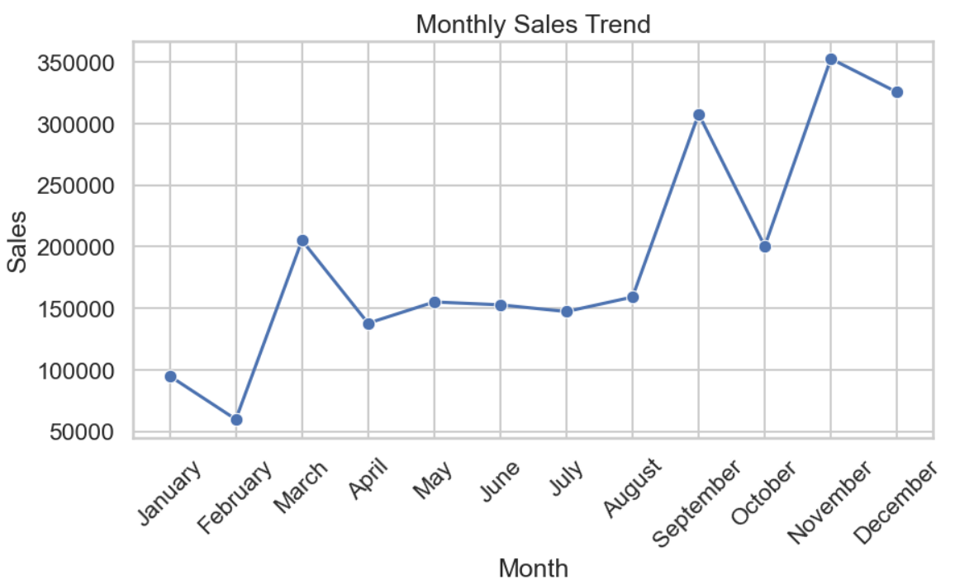

4.7 Top Sub-Categories by Sales
The top-performing sub-categories contribute significantly to total sales and represent high-demand product segments.
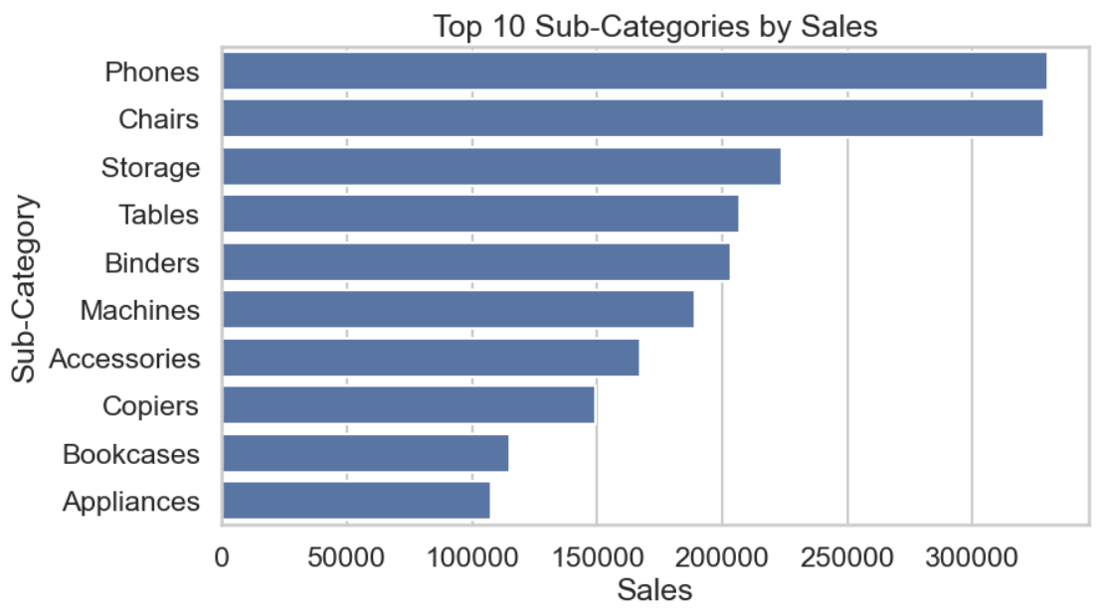
4.8 Sales vs Profit Relationship
A positive relationship between sales and profit is observed. However, some high-sales transactions result in low or negative profit, indicating the influence of discounts or cost factors.
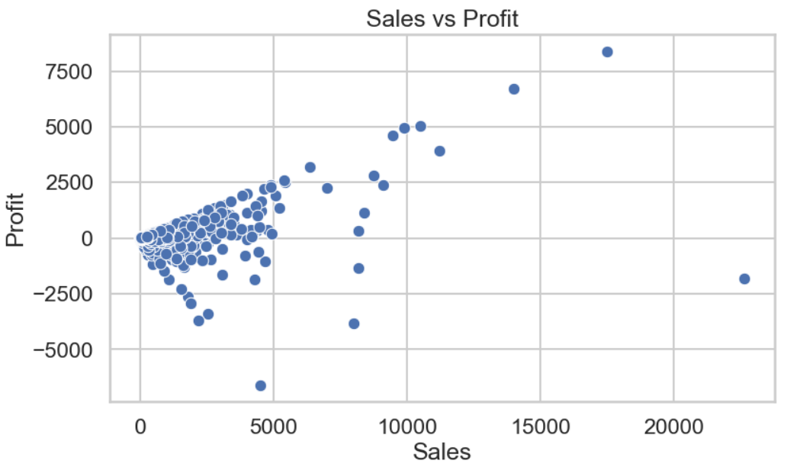

4.9 Discount vs Profit Analysis
A negative relationship between discount and profit is observed. Higher discounts often lead to reduced profitability and sometimes losses.
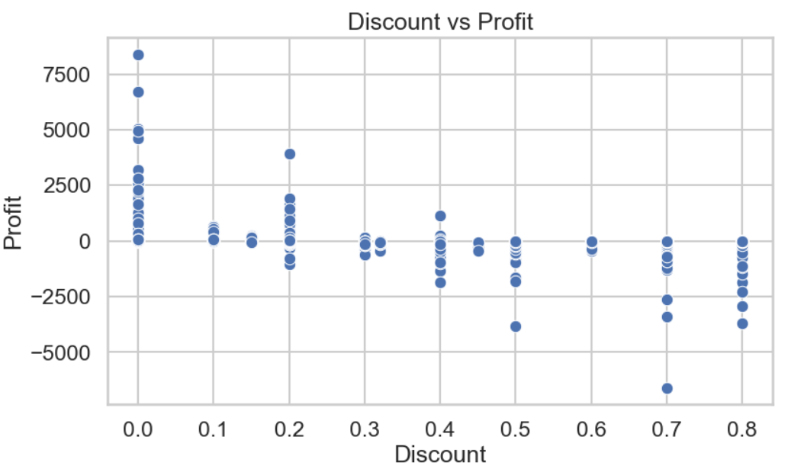
4.10 Correlation Analysis
The correlation heatmap shows that:
- Sales and Profit are positively correlated
- Discount negatively impacts Profit
- Quantity has a weaker relationship with Profit
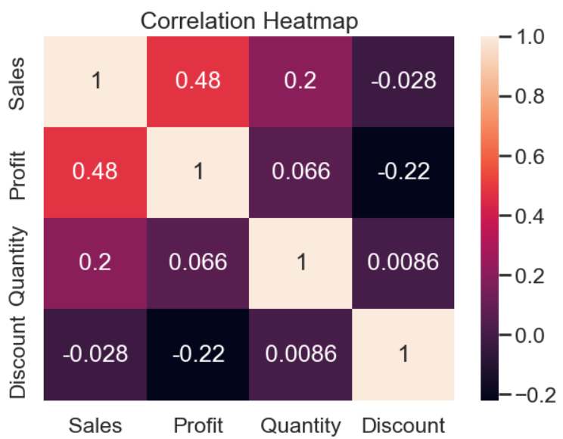
4.11 Dashboard Visualization
An interactive dashboard was developed using Power BI to provide a comprehensive and intuitive overview of retail sales performance. The primary objective of the dashboard is to transform complex data into meaningful visual insights, enabling efficient analysis and supporting data-driven decision-making.
The dashboard includes the following key performance indicators (KPIs):
- Total Sales – represents the overall revenue generated
- Total Profit – indicates the net profitability of the business
- Total Orders – reflects the total number of transactions
These KPIs provide a clear and concise overview of overall business performance.
To gain deeper insights, the dashboard incorporates multiple visualizations covering various analytical perspectives:
- Category-wise sales performance
- Region-wise profit analysis
- Monthly sales trend analysis
- Customer segment distribution
- Top-performing sub-categories
Interactive slicers for category and region are integrated to enhance user experience, allowing dynamic filtering and detailed exploration of specific segments within the dataset.
Overall, the dashboard serves as a centralized analytical tool that effectively summarizes the results of the exploratory data analysis, providing clear, actionable insights in a visually engaging and user-friendly format.
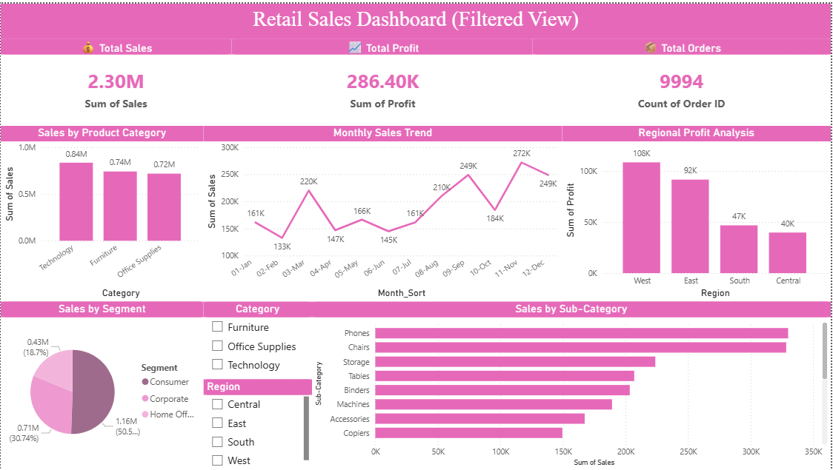

5. Key Insights
- Technology category contributes highest revenue
- West region shows maximum profitability
- Sales show seasonal trends across months
- High discount levels significantly reduce profit margins
- Consumer segment contributes the highest share of total sales
6. Business Recommendations
- Focus on expanding Technology category products to maximize revenue
- Improve performance in underperforming regions through targeted strategies
- Optimize discount policies to avoid unnecessary profit loss
- Leverage seasonal trends for better inventory and marketing planning
- Reduce excessive discounts
6.1 Limitations
- The dataset is limited to historical transactional data and does not include external factors such as market trends, economic conditions, or competitor analysis.
- The analysis is based on available features and may not capture all variables influencing sales and profit.
- Data quality depends on the source, and any inconsistencies in the dataset may impact the results.

7. Conclusion of phase 1
The analysis provides valuable insights into sales performance, customer behavior, and profitability factors in a retail business. These findings can help organizations make informed decisions regarding pricing strategies, product focus, and market expansion. The project demonstrates the importance of data-driven analysis in improving business outcomes. The analysis demonstrates how data analytics can be effectively used to derive actionable business insights and support strategic decision-making.

Future Work
In the next phase of this project, machine learning techniques will be applied to build predictive models for forecasting future sales. This will help in improving planning, inventory management, and strategic decision-making.

8. Sales Prediction & Machine Learning Model
In this phase, machine learning techniques were applied to build predictive models for forecasting sales. The cleaned dataset from Phase 1 was used to perform feature engineering, data preprocessing, and model development.

8.1 Feature Engineering
New time-based features were created from the Order Date column, including Month and Year. These features help capture seasonal patterns and trends in sales data.
Categorical variables such as Category, Region, and Segment were encoded using one-hot encoding to make them suitable for machine learning models.

8.2 Model Building
Two machine learning models were developed to predict sales:
- Linear Regression: A baseline model used to capture linear relationships between features and sales.
- Random Forest Regressor: An advanced model capable of capturing non-linear relationships and interactions between variables.
The dataset was split into training and testing sets to evaluate model performance effectively.

8.3 Model Evaluation
The models were evaluated using the following metrics:
- Mean Absolute Error (MAE)
- Root Mean Squared Error (RMSE)
- R-squared (R² Score)
The results are summarized below:
Model | R² Score
Linear Regression | 0.019
Random Forest | 0.213

9. Final Business Recommendations
Based on both exploratory data analysis and machine learning model insights, the following recommendations are proposed:
- Focus on high-performing product categories such as Technology to maximize revenue
- Optimize discount strategies to avoid reducing profit margins
- Strengthen operations in high-performing regions such as the West
- Improve performance in low-performing regions through targeted strategies
- Use predictive insights for better inventory planning and demand forecasting
- Leverage customer segmentation to enhance marketing strategies

10. Conclusion of phase 2
This project demonstrates how data analysis and machine learning techniques can be combined to extract meaningful insights and predict future sales trends. The Random Forest model provides accurate predictions and highlights key factors influencing sales.
The integration of exploratory data analysis, visualization, and predictive modeling enables better decision-making, improved business strategies, and enhanced overall performance.

